**Fertilizer Recomentation System for Disease Prediction**

# Agriculture is the most important sector in today’s life. Most plants are affected by a wide variety of bacterial and fungal diseases.

Diseases on plants placed a major constraint on the production and a

Interactive user interface to upload images

Admin can view the

recommended fertilizer

through gmail

Interactive user interface to upload images

Improves productivity



### Before you collaborate

A little bit of preparation goes a long way with this session. Here’s what you need to do to get going.

**10 minutes**

**Team gathering**

**A**

Define who should participate in the session and send an invite. Share relevant information or pre-work ahead.

**Set the goal**

**B**

Think about the problem you'll be focusing on solving in the brainstorming session.

**Learn how to use the facilitation tools**



**C**

Use the Facilitation Superpowers to run a happy and productive session.



**[Open article](https://support.mural.co/en/articles/2113740-facilitation-superpowers)**

### 1

**Define your problem statement**

What problem are you trying to solve? Frame your problem as a How Might We statement. This will be the focus of your brainstorm.

**5 minutes**

**PROBLEM**

1. In agricultural aspects, if the plant is affected by leaf disease, then it reduces the growth and productiveness. Generally, the plant diseases are caused by the abnormal physiological Functionalities of plants.
2. People who Grow Crops and facing Issues of Plant Disease .
3. The Traditional methods of Fertilizer prediction and Disease analysis are Expensive and takes a lot of time .

### Key rules of brainstorming

To ru an smooth and productive session

### 2

**Brainstorm**

Write down any ideas that come to mind that address your problem statement.

**10 minutes**

### Guru Prasad M K

Website for Fertilizer recommendation

Identify the disease

Determining best fertilizer

Pre-trained model for image classification

User friendly website

It reduces man power

Smart solution to solve the problem

It simplifies the farmers work

### Gowtham Sidharth S

Fertilizer Recommendation

Deep learning based mathematical model for detecting diseases

Early detection and management of problem

Better utilization of available resources

**TIP**

You can select a sticky note and hit the pencil [switch to sketch] icon to start drawing!

**Gokul Krishnan J**

Making revolutionary changes in agriculture field

Build keras image classification model

They can find the diseases at early stages

Cost of using this application is less

## Jegadeesh M

Useful to people with no prior knowledge

It will save time

Instant solution

### 3

**Group ideas**

Take turns sharing your ideas while clustering similar or related notes as you go. In the last 10 minutes, give each cluster a sentence-like label. If a cluster is bigger than six sticky notes, try and see if you and break it up into smaller sub-groups.

**20 minutes**

# Category 1

Pre-trained model for image classification

Website for Fertilizer recommendation

Identify the disease

Cost of using this application is less

Interactive user interface to upload images

Interactive user interface to upload images

Portal for farmers

Useful to people with no prior knowledge

Category 3

Category 2

**4**

**Prioritize**

Your team should all be on the same page about what's important moving forward. Place your ideas on this grid to determine which ideas are important and which are feasible.

**20 minutes**

**After you collaborate**

You can export the mural as an image or pdf to share with members of your company who might find it helpful.

Build keras image classification model

**Quick add-ons**

1. **Share the mural**

**Share a view link** to the mural with stakeholders to keep them in the loop about the outcomes of the session.

1. **Export the mural**

Export a copy of the mural as a PNG or PDF to attach to emails, include in slides, or save in your drive.

Pre-trained model for image classification

Admin can view the recommended fertilizer through gmail

Better utilization of available resources

Making revolutionary changes in agriculture field

Deep learning based mathematical model for detecting diseases

Website for Fertilizer recommendation

Early detection and management of problem

Deep learning based mathematical model for detecting diseases

They can find the diseases at early stages

Interactive user interface to upload images

major threat to food security. Hence early and accurate identification of plant diseases is essential to

Stay in topic.

Defer judgment.

Encourage wild ideas.

Listen to others.

Portal for farmers

**Keep moving forward**

**Strategy blueprint**

Define the components of a new idea or strategy.

**[Open the template](https://app.mural.co/template/e95f612a-f72a-4772-bc48-545aaa04e0c9/984865a6-0a96-4472-a48d-47639307b3ca)**

**Customer experience journey map**

Understand customer needs, motivations, and obstacles for an experience.

**[Open the template](https://app.mural.co/template/b7114010-3a67-4d63-a51d-6f2cedc9633f/c1b465ab-57af-4624-8faf-ebb312edc0eb)**

**Strengths, weaknesses, opportunities & threats**

Identify strengths, weaknesses, opportunities, and threats (SWOT) to develop a plan.

**[Open the template](https://app.mural.co/template/6a062671-89ee-4b76-9409-2603d8b098be/ca270343-1d54-4952-9d8c-fbc303ffd0f2)**

Useful to people with no prior knowledge

Instant solution

Making revolutionary changes in agriculture field

**Importance**

If each of these tasks could get done without any difficulty or cost, which would have the most positive impact?

Better utilization of available resources

Admin can view the recommended fertilizer through gmail

Instant solution

# ensure high quantity and best quality. In recent years, the number of diseases on plants and the degree of harm caused has increased due to the variation in pathogen varieties, changes in cultivation methods, and inadequate plant protection techniques.

Go for volume. If possible, be visual.

|  |  |
| --- | --- |
|  |  |
|  |  |

It simplifies the farmers work

Early detection and management of problem

Cost of using this application is less

Utilizing of Resources

Recommends Fertilizers

Useful to Farmers

Cost of using this application is less

Smart solution to solve the problem

They can find the diseases at early stages

**[Share template feedback](https://muralco.typeform.com/to/CiqaHVat?typeform-source=app.mural.co)**

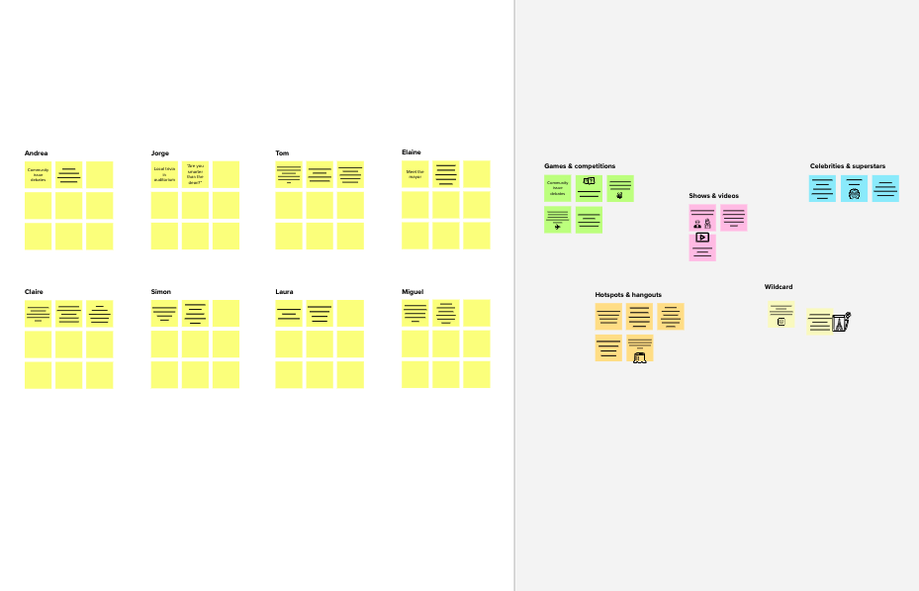

**Template**

Simple UI

Reduces the Cost

Improves profiit

**10 minutes** to prepare

**Feasibility**

Regardless of their importance, which tasks are more feasible than others? (Cost, time, effort, complexity, etc.)

**[1 hour](https://muralco.typeform.com/to/CiqaHVat?typeform-source=app.mural.co)** [to collaborate](https://muralco.typeform.com/to/CiqaHVat?typeform-source=app.mural.co)

**2-5 people** recommended

**Need some inspiration?**

See a finished version of this template to kickstart your work.

**[Open example](https://app.mural.co/template/e5a93b7b-49f2-48c9-afd7-a635d860eba6/93f1b98d-b2d2-4695-8e85-7e9c0d2fd9b9)**